**Commonly Used PowerShell Cmdlets (Master List)**

1. **Get-Process**

# Displays a list of running processes on the system.

1. **Get-Service**

# Shows the status and details of services on the system.

1. **Stop-Service**

# Stops a running Windows service.

1. **Start-Service**

# Starts a stopped Windows service.

1. **Get-EventLog**

# Retrieves entries from Windows event logs.

1. **Get-Item**

# Gets information about a specific file, folder, or registry key.

1. **Set-Location**

# Changes the current working directory or path.

1. **Copy-Item**

# Copies files, folders, or other items to a new location.

1. **Move-Item**

# Moves files, folders, or items to a new location.

1. **Remove-Item**

# Deletes files, folders, or other items.

1. **Rename-Item**

# Changes the name of a file, folder, or item.

1. **Get-Content**

# Reads the content of a file.

1. **Set-Content**

# Writes or replaces content in a file.

1. **Select-String**

# Searches for text patterns in files or strings.

1. **Get-ADUser**

# Retrieves details about Active Directory user accounts.

1. **New-ADUser**

# Creates a new Active Directory user account.

1. **Get-ComputerInfo**

# Displays detailed system information about the computer.

1. **Set-Date**

# Changes the system date and time.

1. **Where-Object**

# Filters objects in the pipeline based on conditions.

1. **Sort-Object**

# Sorts objects in ascending or descending order.

1. **Set-ExecutionPolicy**

# Changes the script execution policy for PowerShell.

1. **Get-Help** # Displays help information about cmdlets, functions, or concepts.
2. **Get-ChildItem**

# Lists files and folders in a directory.

1. **Remove-Item**

# Deletes specified files, folders, or items. *(Duplicate in list)*

1. **Test-Connection**

# Sends ICMP echo requests (pings) to test network connectivity.

1. **Get-NetIPAddress**

# Displays IP address configuration details.

1. **Get-Command**

# Lists all available cmdlets, functions, workflows, and scripts.

1. **Clear-Host**

# Clears the PowerShell screen (same as cls).

1. **Get-History**

# Displays the list of previously executed commands in the current session.

1. **Invoke-History**

# Runs a command from the session history.

**Some practical Screenshots:-**

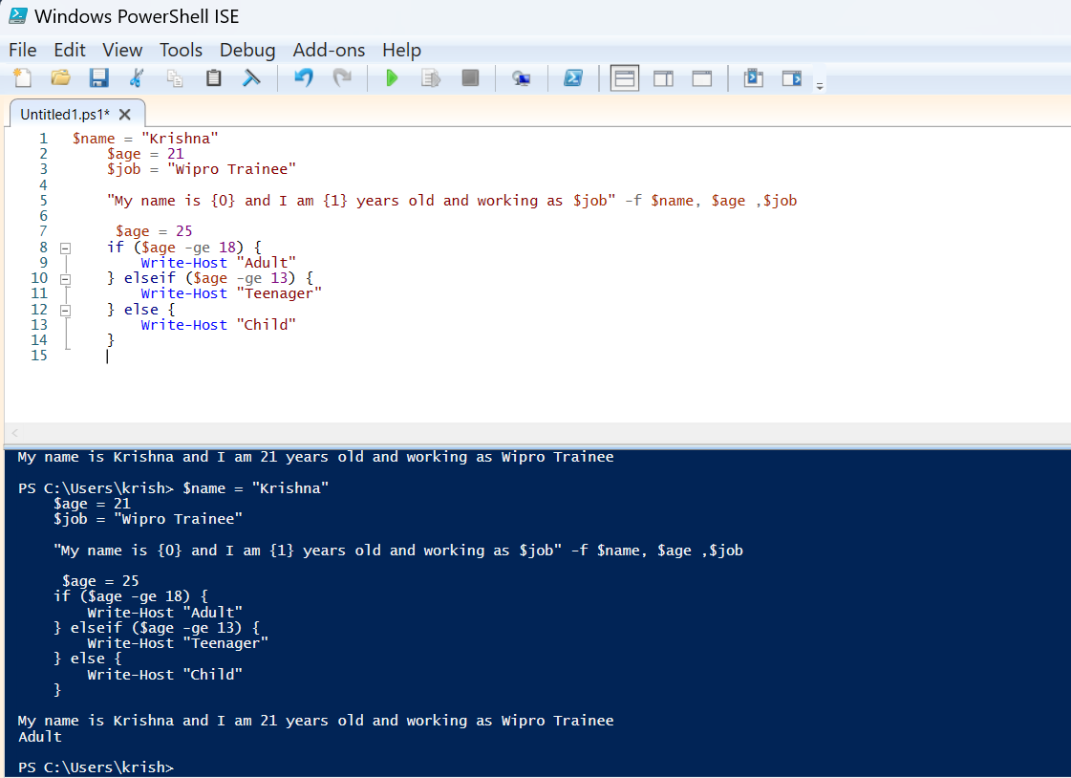

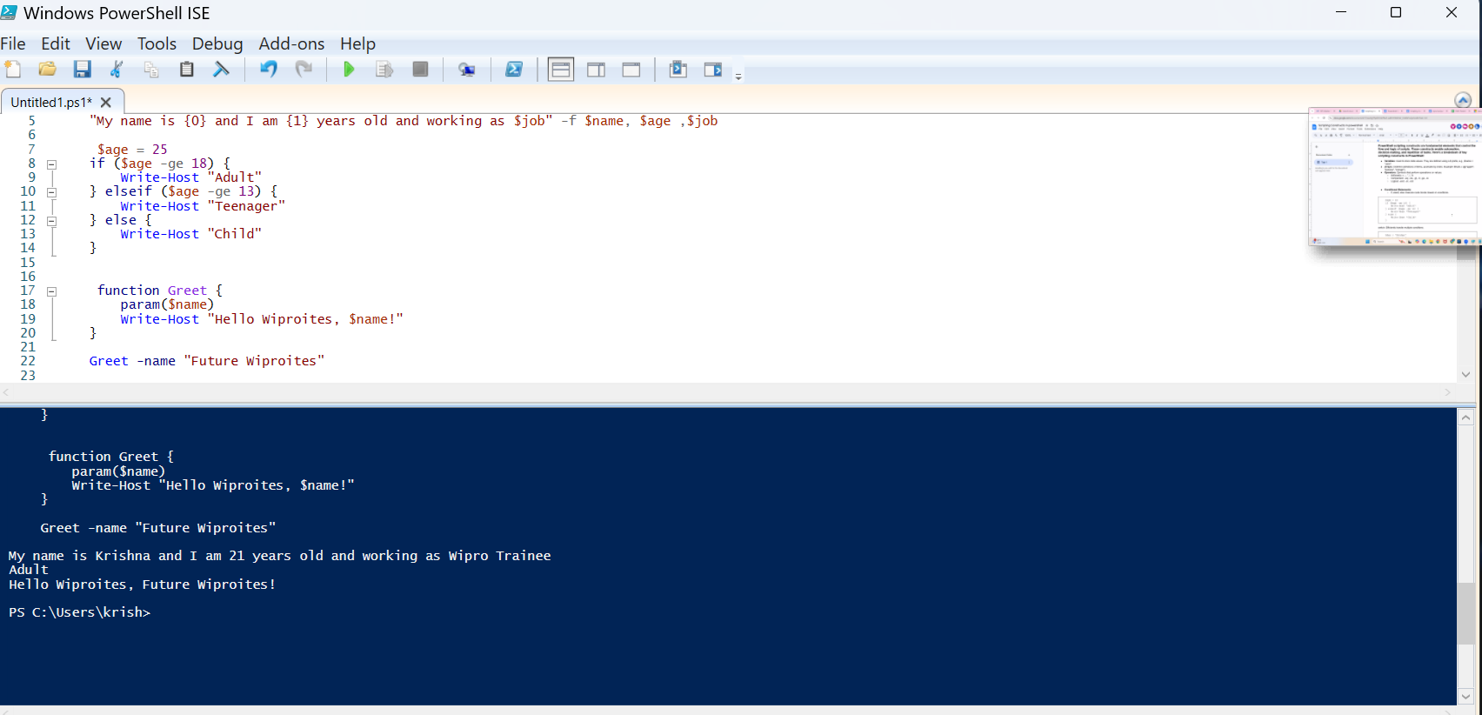

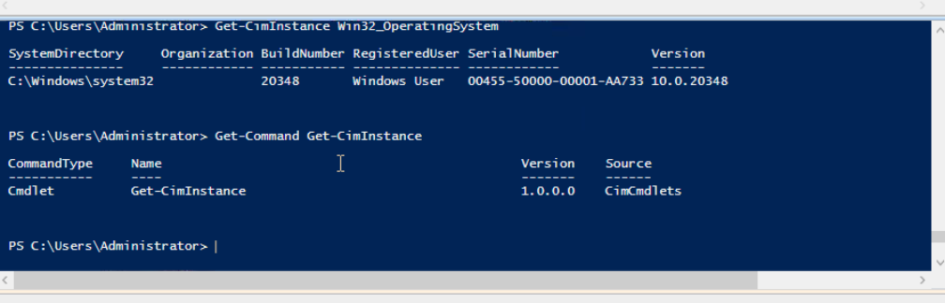

**Some command and their uses :-**

* Get-NetIPConfiguration | Out-File D:\wipropowershell\datafiles.txt -Append # Gets detailed network adapter and IP configuration and saves it to a file without overwriting.
* Get-NetIPConfiguration | Out-File -FilePath D:\aa\wiprofiledwc\netfileipconfigs # Gets network configuration details and saves them to a specified file path.
* Get-Service| Out-File D:\aa\wiprofiledwc\processfile -Append # Lists all services on the system and appends the list to a file.
* Get-PSDrive -PSProvider FileSystem | Out-File D:\wipropowershell\datefilea.txt -Append # Lists all file system drives and appends the info to a file.
* Get-Command | Out-File D:\Demo\datefile.txt -Append # Lists all available PowerShell commands and appends them to a file.
* Get-PSDrive -PSProvider FileSystem | Out-File D:\Demo\datefile.txt -Append # Lists all file system drives and appends the info to a file.
* Get-NetIPConfiguration | Out-File D:\Demo\datefile.txt -Append # Gets network configuration details and appends them to a file.
* Get-PSDrive -PSProvider FileSystem | Out-File D:\Demo\datefile.txt -Append # Lists all file system drives and appends the info to a file.
* Get-ChildItem | Out-File D:\Demo\datefile.txt -Append # Lists files and folders in the current directory and appends them to a file.
* Get-PSDrive -PSProvider FileSystem | Out-File D:\wipropowershell\datafiles.txt -Append # Lists all file system drives and appends the info to a file.
* Get-Service | Out-File D:\Demo\opfilecommands.txt -Append # Lists all services on the system and appends the list to a file.
* Get-Process | Out-File D:\Demo\opfilecommands.txt -Append # Lists all running processes on the system and appends them to a file.